How to install Jenkins in Ubuntu

switch user to root

sudo su –

wget -q -O - https://pkg.jenkins.io/debian/jenkins-ci.org.key | sudo apt-key add -

**sudo** sh -c 'echo deb http://pkg.jenkins.io/debian-stable binary/ > /etc/apt/sources.list.d/jenkins.list'

**sudo** apt-get update

**sudo** apt-get install jenkins

**Jenkins runs on port 8080---- add rule in instance tcp as 8080 in SG.**

open in a browser ip:8080

login to jenkins server

Unlock the Jenkins screen

switch user to jeninks

sudo su - jenkins

cat /var/lib/jenkins/secrets/initialAdminPassword

copy and paste the output in the browser password field

Customize Jenkins Screen for installing the plugins

Choose the **install suggested plugins or select plugins to install**

**Click on any one.**

* Getting Started to the installing the plugins
* Create First Admin User give the details

Username—

Password-__

Confirm Password __

Full Name ___

E-Mail address __

**Click on save and Finish**

**Note:**

**Jenkins folder structure**

**● home dir - /var/lib/jenkins**

**● Main configuration file - /var/lib/jenkins/config.xml**

**● change port number - /etc/default/jenkins**

* **How to integrate the Git hub to Jenkins through to User name and Password**

**Jenkins is a continuous integration and continuous delivery tool i.e CI/CD Tool**

**Login to Jenkins server 🡪** [**http://54.209.110.240:8080**](http://54.209.110.240:8080)

**Give the user name and Password🡪 login**

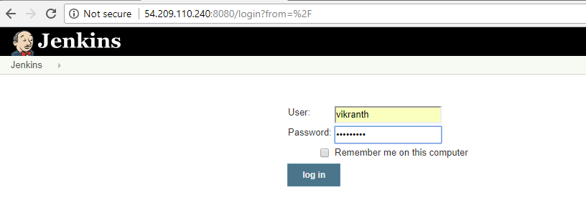**after login to Jenkins -🡪 this is the Jenkins dashboard**

**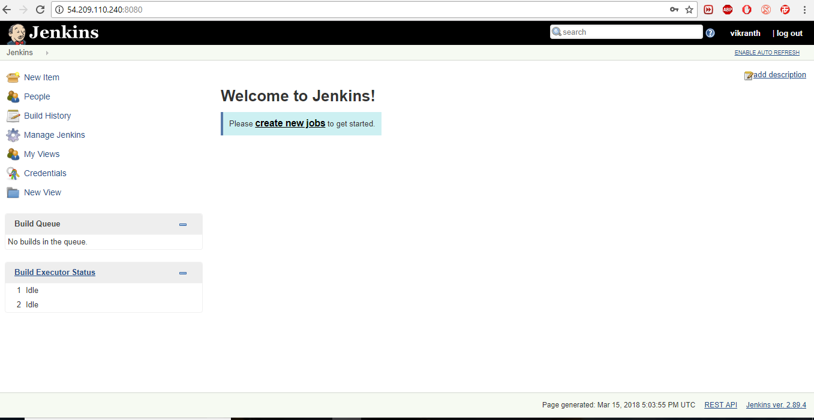  
if u are integrating anything to the Jenkins u should install that particular plugins in the Jenkins**

**so now we are integrating with github🡪 you should install the github integration plugin to ur Jenkins**

**for click on manage Jenkins 🡪 click on Manage Plugins**



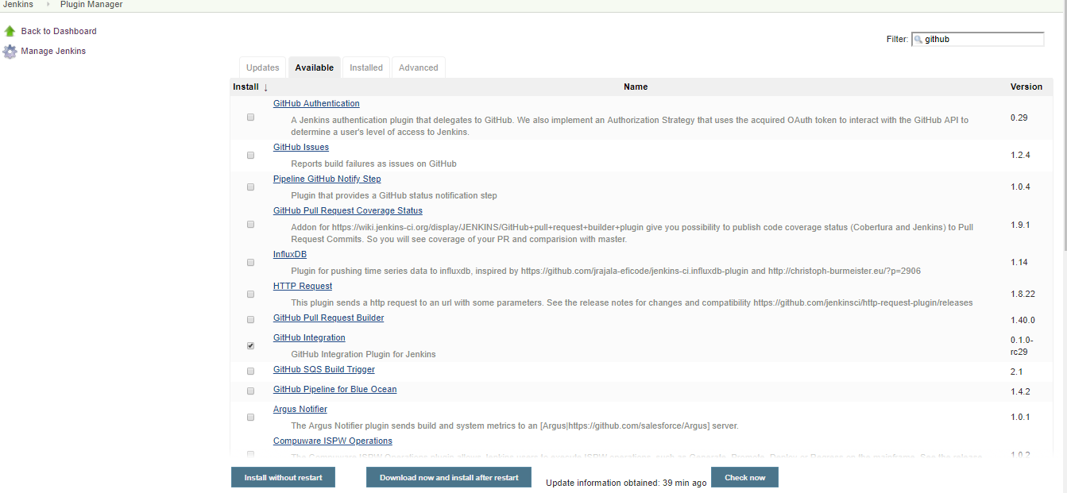

**Click on Available and search on Filter for github Integrator 🡪 clickon that one and click on Download now and install after restart**

**I will automatically restart ur Jenkins server🡪 login to jenkins server**

**Check the that plugin is installed or not**

**Click on installed search on filter for github integrator**

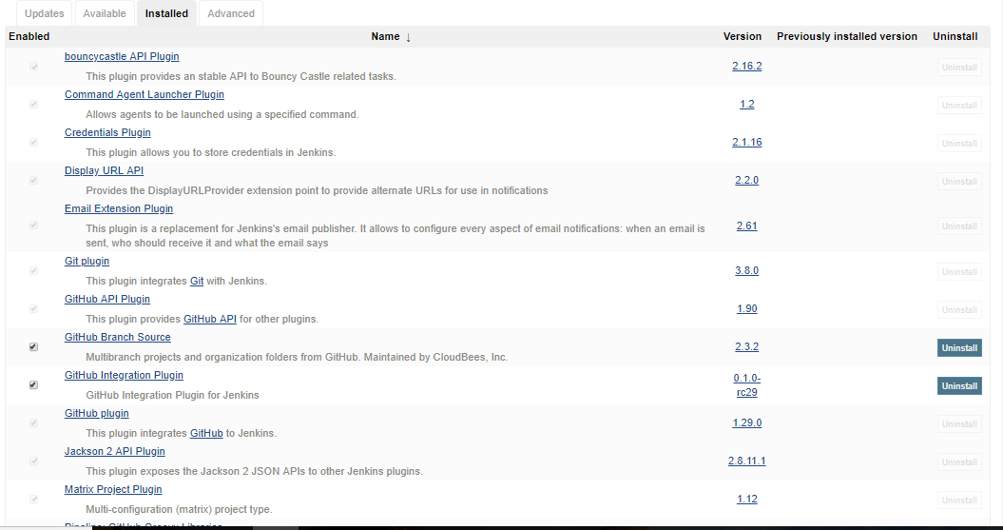

**Now create one new item 🡪 it nothing but job in Jenkins**

**Left side navigation click on create item **

**Enter an item name -🡪 vikranth**

**Select project as a Freestyle project**

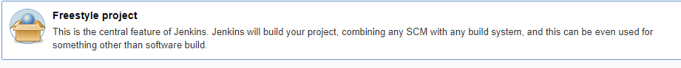

**And click on okay**

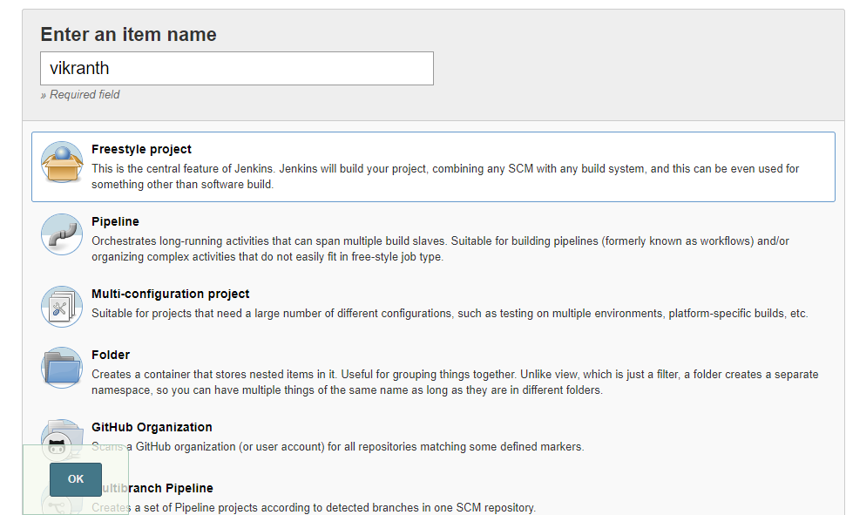

**After that it will redirect to the configure system**

**It has 6 phases i.e**

1. **General 2. Source code Management**
2. **Build Trigger 4. Build Environment**
3. **Build 6. Post-Build action**

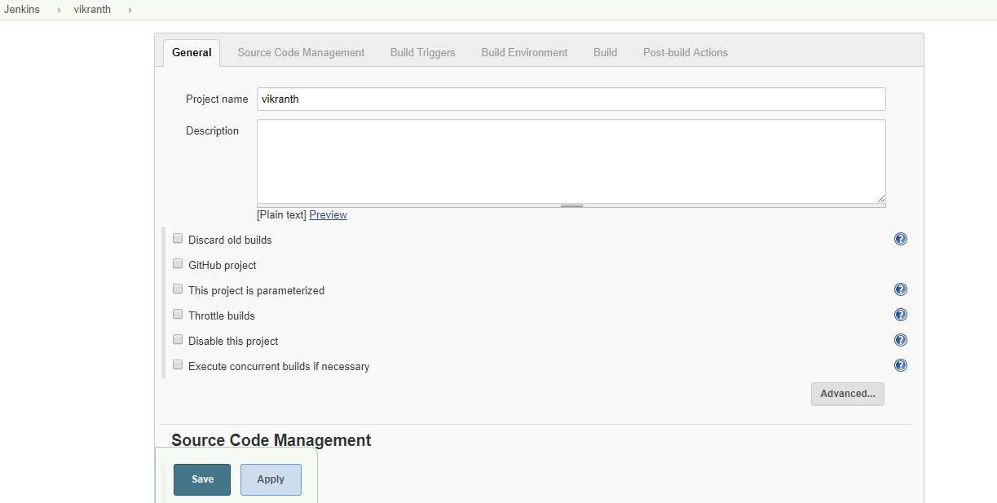

**As per our requirement we have to integrate the git hub to Jenkins**

**So gitbub is scm now click on source code management 🡪 and click on git**

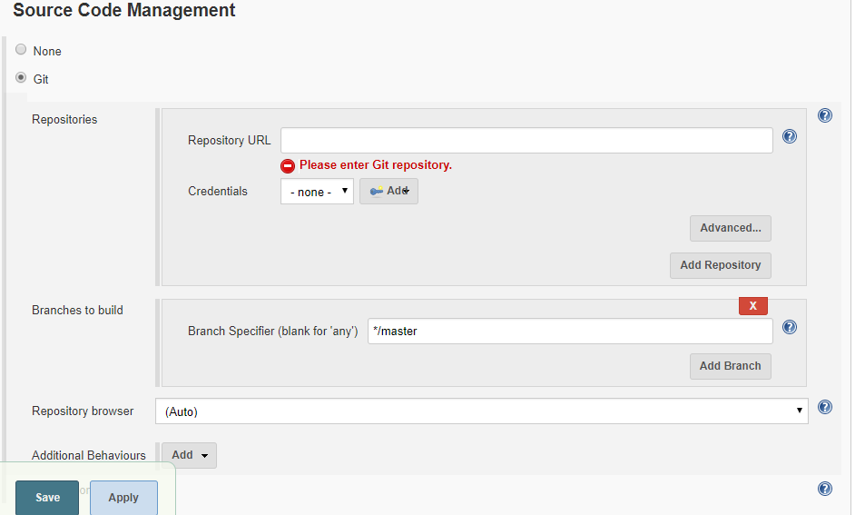

**I am having github repo i.e bank now I am copying the github repo and pasting to the Jenkins repo url** 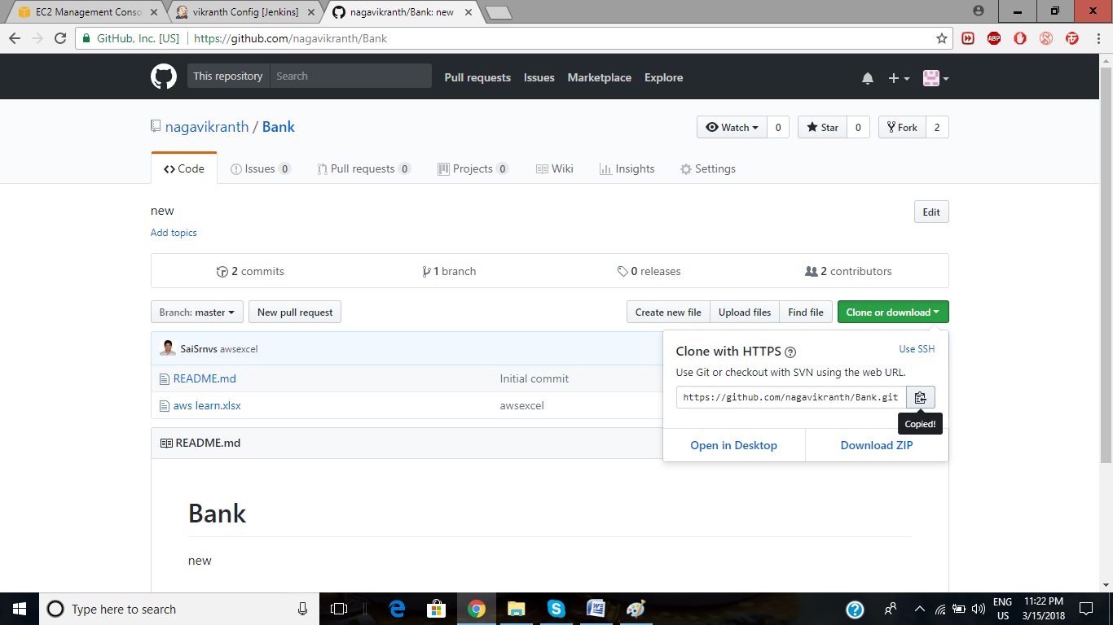

**Give the Repository URL https://github.com/nagavikranth/Bank.git**

**After that go to the credentials click on add**

**select Jenkins**

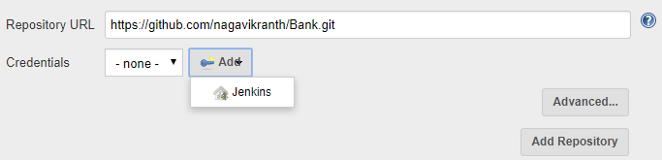

**Now click on Jenkins it opens on page**

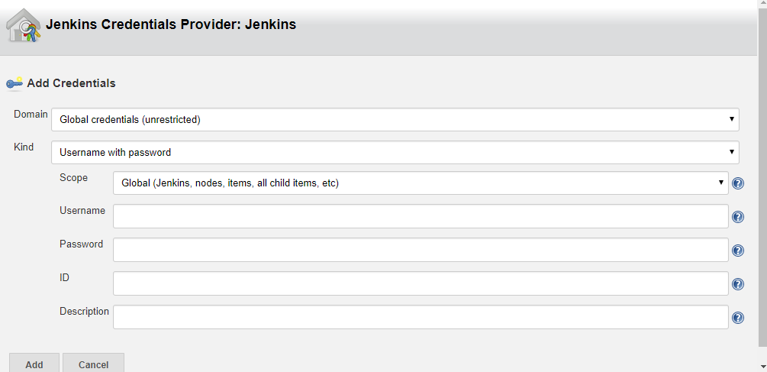

**Kind select ur option in the drop down**

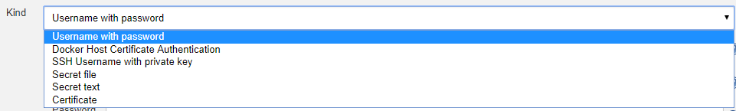

**Now I am selecting as username with password**

**Here u has to give github user name and password**

**After that click on add**

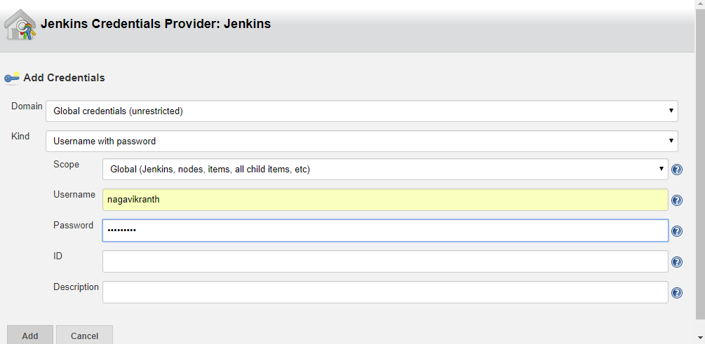

**After that it will in scm page**

**Now click on credentials take dropdown as ur username and password**

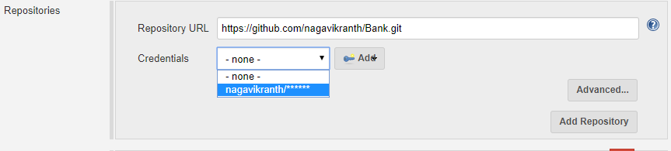

**Now click on apply and save**

**Upto now we are given the git hub repo details to the Jenkins**

**Now go to git hub repo settings-🡪 left side navigation click on integration & services**

**Now click on add services dropdown 🡪 search in filter service as Jenkins github plugin**

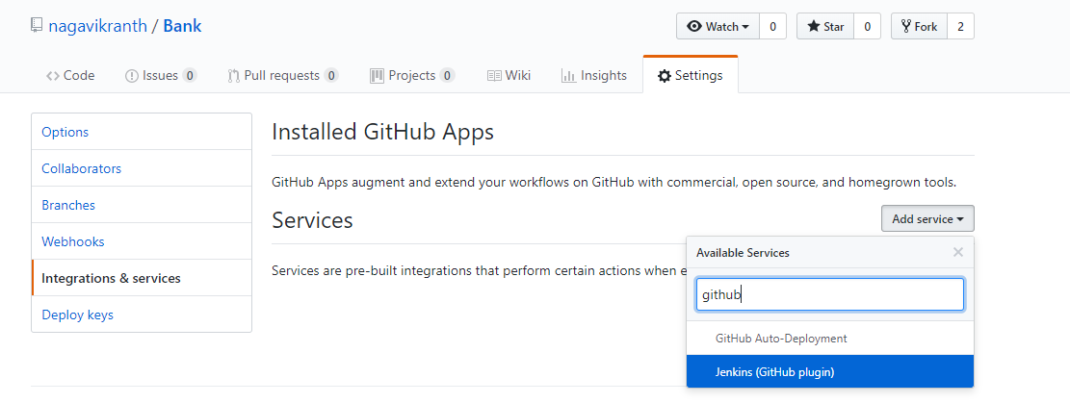**click on that after we will get confirmation password to add the service**

**After that give the Jenkins hook url i.e**

**Example : url ur Jenkins/github-webhook/**

**http://54.209.110.240:8080/ github-webhook/ -🡪 after that click on add service**

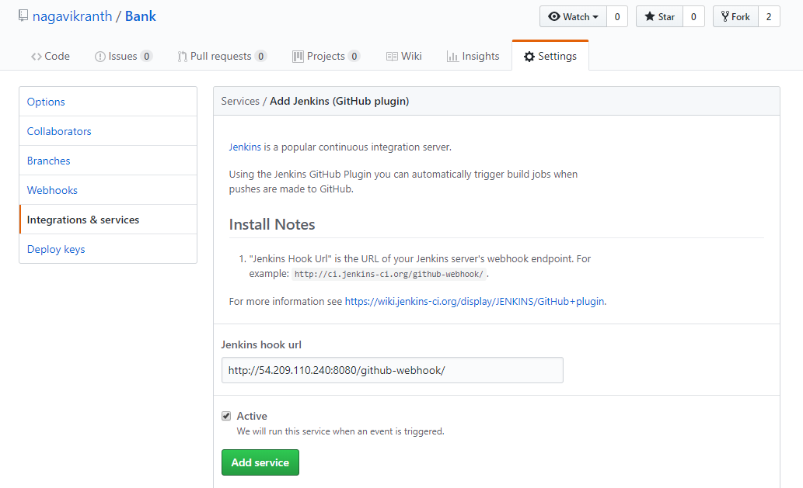

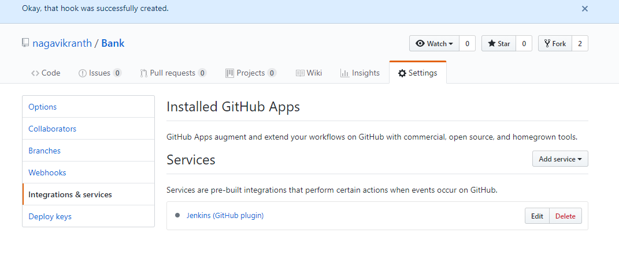

**Now the hook was successfully created**

**Herer now when ever ur committing and pushing into the github automatically build should be created in the Jenkins job**

**For that go to the Jenkins job click on configure 🡪 build triggers**

**Checkout the Github hook trigger for GITscm polling🡪 apply and save**

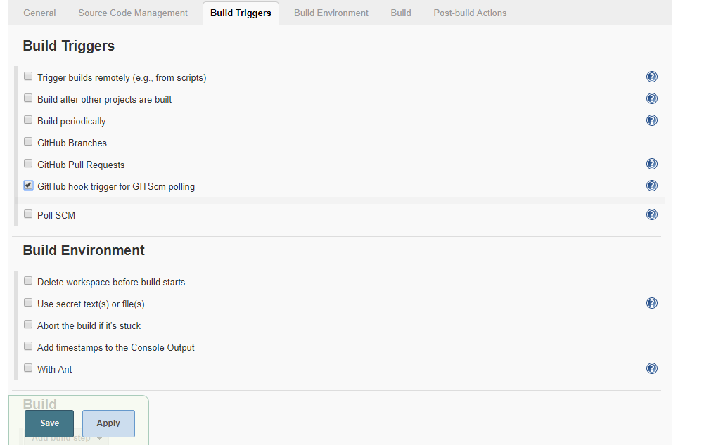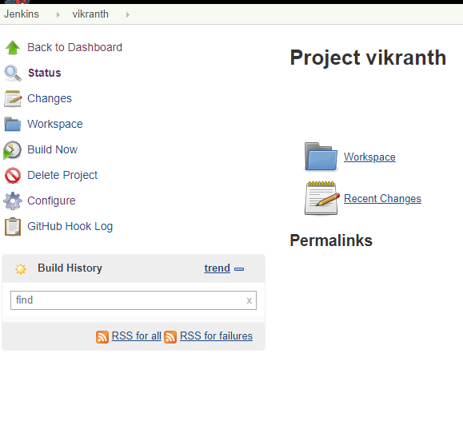

**Now add and commit and push the file to the github repo**

**Check automatically build created in build History**

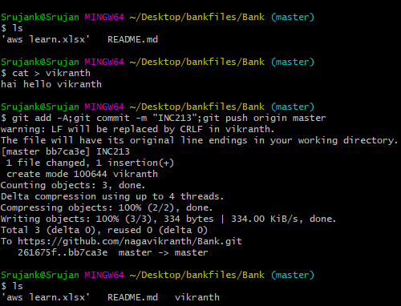

**Checkout in Jenkins**

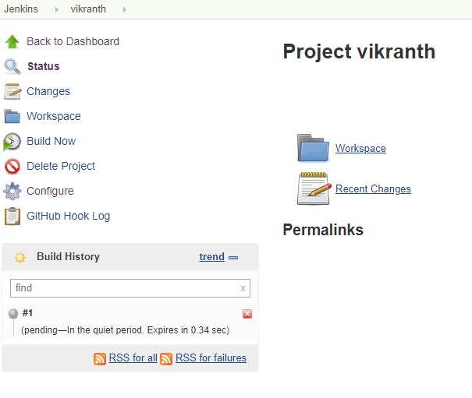

**Gray ball indicate the initializing the build **

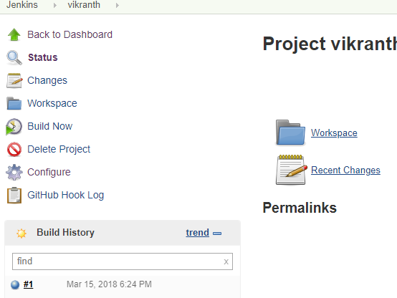

**It is created build automatically**

**This is the process to integrating git hub to Jenkins through user name and password**

**Blue ball indicate the Build was created successfully **

**Click on the blue ball it will show the console output of the build**



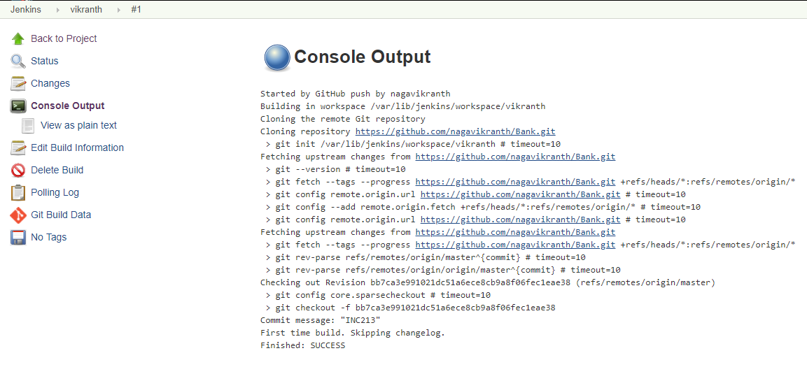

**--------------------------------------------------------------------------------------------------------------------**

* **How to integrate git hub and Jenkins through SSH key**

**Before integrate that u should install the github integrator in the Jenkins**

**And github Jenkins service in git hub**

**Generate the ssh key in ur local repo**

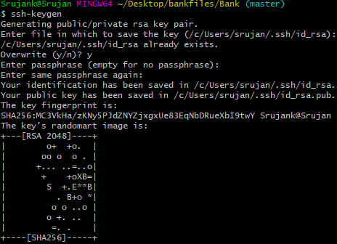

**Copy the public key and add deploy key the paste the key and active the key in git hub**

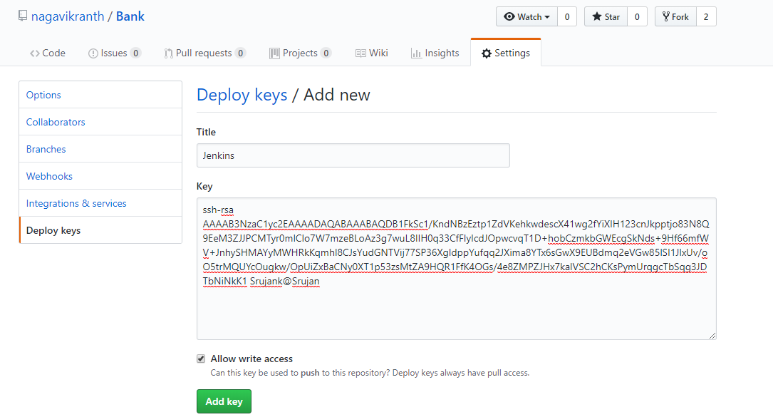

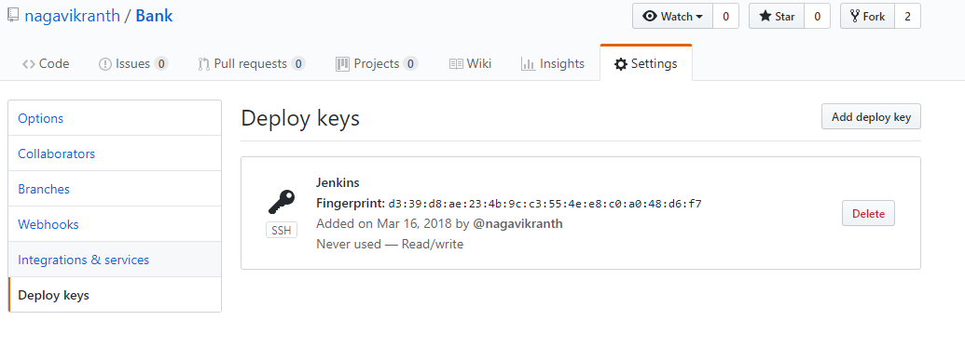

**Active the deploy key 🡪 run command in git bash**

**ssh –T** [**git@github.com**](mailto:git@github.com)

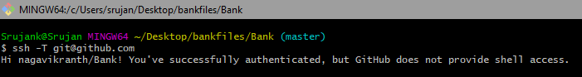

**Now check in git hub deploy keys**

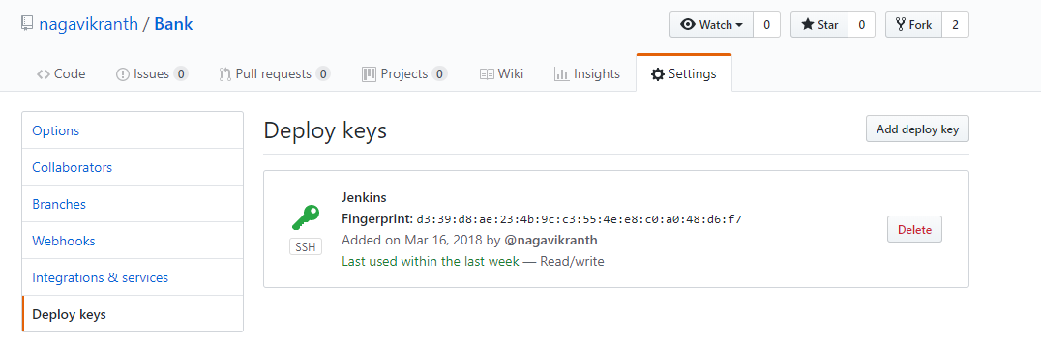

**It is active now**

**Now Copy the private key and go to the Jenkins job🡪 configure system🡪 SCM🡪 add 🡪 Jenkins Home🡪 choose kind as SSH and private key give the details and add**

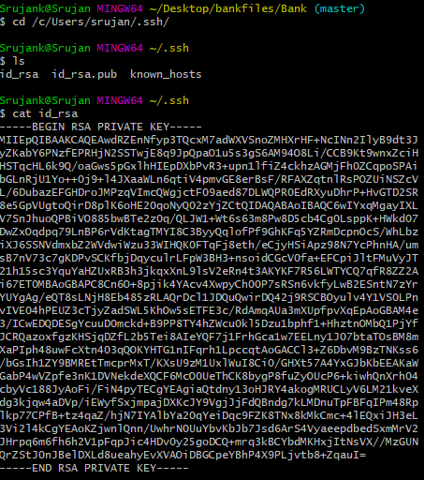

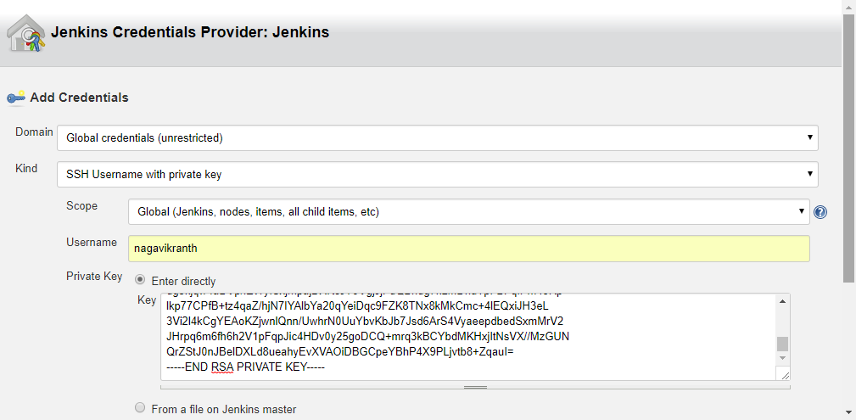

**Add 🡪 Choose credentials as git user name**

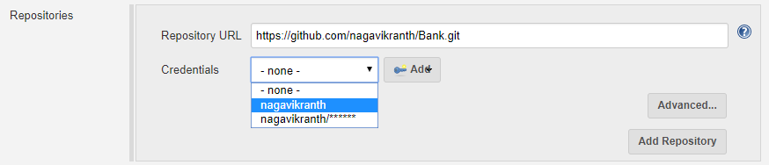

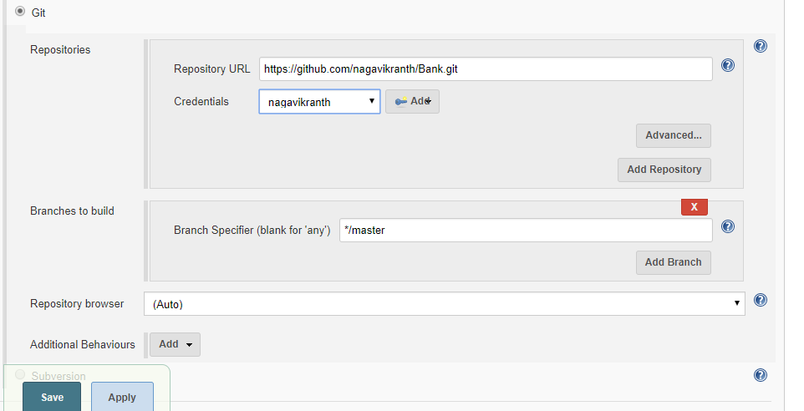

**Apply and save**

**Now create file and add,commit,push the file to git hub**

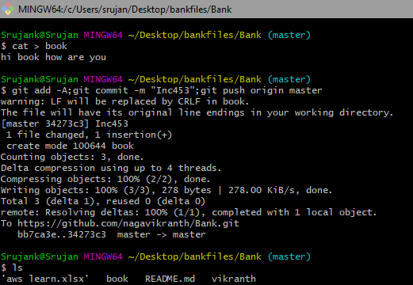

**Check on Jenkins**

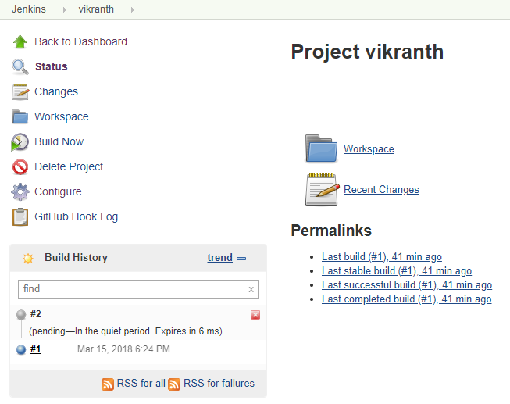

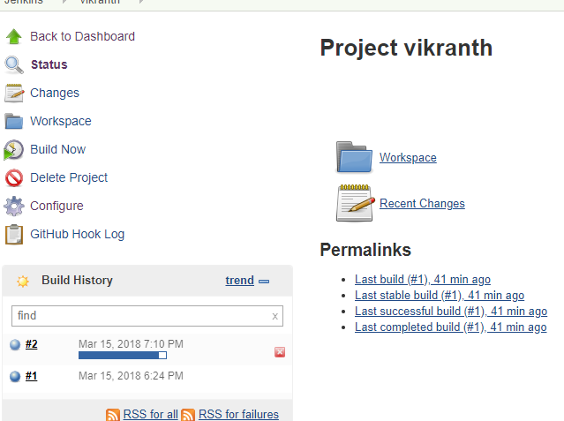

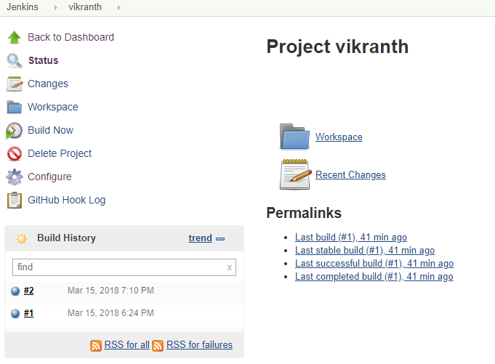

**Build automatically through git ssh private key**

**Click on console out**

